Dear Lions,
Imagine the joy of a grandparent who gets to see their grandchild for the first time. Imagine the pain of a father who once provided for his family, but now no longer can because a preventable disease stole his sight. These are the reasons why SightFirst is dedicated to providing eye care to underserved communities and fighting preventable blindness.
One of our key partners in SightFirst is the World Health Organization (WHO). Through our partnership with the WHO, Lions Clubs International Foundation (LCIF) receives technical support for SightFirst initiatives as well as three other areas of importance: our Global Childhood Blindness Initiative, our Diabetic Eye Disease Initiative, and eye care initiatives in China.
The results of the partnership are impressive. LCIF has established 45 child-friendly eye care centers in 30 countries, developed a tool to help countries improve upon the measures of diabetes and diabetic retinopathy care, and eliminated trachoma as a public health threat in China. Because of what the WHO makes possible for SightFirst and our other LCIF initiatives, I am proud to announce the renewal of our agreement with the WHO.
The partnership LCIF has with the WHO has been tremendously successful and we are very pleased to have extended our relationship. We are proud to be working with an organization who wants to see progress as much as we do and we look forward to future achievements.
Sincerely,
Dr. Jitsuhiro Yamada
Chairperson, Lions Clubs International Foundation
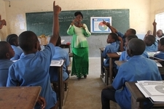
A Billion Dollars in Service
Recently, LCIF marked a milestone, awarding more than US$1 billion in grants since its founding in 1968. Countless individuals and communities have been improved due to Lions and LCIF, including more than 15 million young people who have been exposed to the Lions Quest program.
Lions Quest has taught valuable life lessons to children all over the world. Based on Social and Emotional Learning (SEL), Lions Quest is teaching children to understand and manage emotions, achieve goals, show empathy, and create positive relationships. Lions Quest also teaches students how to avoid drugs and alcohol.
Continuing to support LCIF makes milestones like this possible and supports the education of children worldwide. Watch Lions Quest: New Growth, Proven Success to learn more!
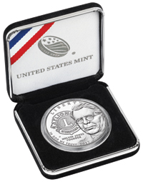
Own a Limited-Edition Lions Clubs Centennial Commemorative Silver Dollar Coin
For a limited time only, you can order discounted Centennial Commemorative Coins and pick them up at the International Convention in Chicago! We’re lowering the price of these keepsake coins when you place your order now so you’ll save money on the coins and eliminate shipping costs. You can order a coin with proof finish for US$49.95 or an uncirculated finish for US$48.95. There is a US$2.95 handling fee per order.
Own a piece of Lions history, celebrate our Centennial and support the life-changing work of Lions around the world. Order your commemorative coins today! Hurry—this offer expires April 19, 2017.
Recruiting: Club LCIF Coordinators
The Club LCIF Coordinator is an ambassador for LCIF at the club level. This person shares LCIF stories, motivates fellow Lions to support LCIF, and enables LCIF to advance its humanitarian work both locally and globally. This position is crucial to the promotion of our foundation. Talk to your club president today if you are interested in volunteering for this exciting new position.

