One Three Three
District Newsletter
4th September 2017.

Ready, Steady…GO

HERE WE GO !

Welcome to One Three Three, a new Newsletter for our New District.
We plan to produce an issue every Monday morning so that you will always be up to date on District and Club activities. We hope to bring you news, views and information about Lions Clubs every week including a blog form our District Governor Teresa, her diary for the coming week, information on District projects and activities and the latest information from Lions Clubs International.
Most of all, we hope that Clubs will use this newsletter as a channel of communication between Lions Clubs in our District.

We welcome news, comments and images about YOUR club and YOUR projects.
Please send your text and images to fcorr100@gmail.com to arrive by 9am on Friday for the next week’s issue.

FROM THE DISTRICT GOVERNOR
Good morning, Lions of District 133,

This is our first official Newsletter of our new District. What a Centennial Year we have had so far and we have another ten months to go so lots more time for everyone to get a Centennial Project up and running. On behalf of the District Governor Team, I want to thank you all for your support and good will as we enter the second half of our Centenary year.

I hope everyone has had a great summer. The summer was very busy here at home for me in little old Ballinhassig, as I got to grips with the administration for the role of District Governor in our new District 133. But all’s well that ends well, and I believe that we are entering into a new era of transformation/change in our District. The message from our International
President for year takes us back to basics; it is “We Serve”. Sometimes we forget about the service projects and services we can give to our communities and get caught up in raising funds. So let’s make a big effort to see what service we could provide in our communities/District.

The District Governor Team of Frank, Bernard andmyself have been busy getting our schedules together to get our Club visits under way. The fun really is beginning.

Over the last few weeks Brian Thoma (Carrigaline Lions Club) who has agreed to

take on the role of Global Leadership Coordinator and myself have been travelling to various parts of the country to meet up with your new Zone Chairpersons for the newly reorganised zones. Your Zone Chairs will be in contact with the Clubs in the individual zones over the coming weeks and I would ask you to support them in their roles and let them support you in whatever way they can. We are all here to support and help one another.

Last Saturday the 26th August I took myself off down to Tintern Abbey, in Co. Wexford to join and support Wexford Lions Clubs in one of their three day walking events. What a great day it was. Great fun and great support for the club locally. I walked with a gentleman who was there to support Wexford Lions Club as he had been a guest at Trabolgan this year and had a wonderful time and wished to give something back. It was really lovely to spend the time walking and chatting with him.

Well this is a brief little outline of what I have been up to over the summer and recent weeks, our idea is to let you know on a weekly basis what has been going on while it is all fresh. So if you have anything you want advertised or just to tell people about do contact Frank Corr (fcorr100@gmail.com) so that we can all share what we are up to.

Have a great week, stay safe and healthy.

Warmest regards
Love and light
Teresa
District Governor
District 133 Ireland

Club Visits for the week commencing 4th September 2017.

Monday 4th September Shannon
Tuesday 5th September Balbriggan
Wednesday 6th September Gort
Thursday 7th September Ashbourne

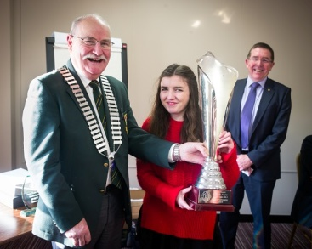

Time to find young ambassadors

All clubs are invited to find a successor to Chelsea Gibson, our District Young Ambassador for 2017.

The aim of the Young Ambassadors Award Programme, which operates throughout Europe, is to recognise, encourage and support young people who are actively involved in the welfare of the community, supporting the best of our Lions’ ideals. In previous years candidates have been involved in helping young and old people, disabled, able-bodied and disadvantaged, and have organised projects in areas such as conservation, and the promotion of healthier lifestyles.

It is very easy for candidates to apply. They simply download the application form from www.lionsdistrict105i.com, fill it in and return it to their local Lions Club. At this stage Clubs should have received a Club Officers Guide that explains the Competition in detail, together with some promotional material to assist in promoting the Competition locally.

The Competition is open to individuals of either gender who have reached their 15th birthday but have not reached their 19th birthday on or before 30th June 2018. A bursary of €600 is available to the District winner. The bursary can be used for a project of the winner’s choice. The winner will also win the Tom Conway Perpetual Trophy (to be held for one year) and a smaller trophy to keep. The District winner will represent District 133 at the European Finals to be held at the Europa Forum Skopje, Macedonia in October 2018. In preparation the District 133 winner will participate in the UK finals.
Draft Directory

A draft of the 2017/18 District Cabinet & Club Directory has been circulated to all clubs.. All details have been downloaded from the Oak Brook database and reflect the information supplied by Clubs to Oak Brook. The draft is being circulated to enable Clubs to ensure that any errors or omissions in the Oak Brook database are corrected now. Please check the information relating to you and your Club in the draft Directory including the venue and times of Club Meetings. Ideally, for all individuals listed there should be home and mobile telephone numbers and email addresses. If there are any errors or omissions, please arrange for your Club Secretary to update the Oak Brook file. This should be done online. All amendments should be made not later than Friday, 15 September.

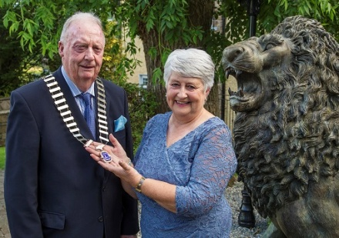

Rocrea Jubilee President

Catherine Lorigan,outgoing president of Roscrea Lions Club hands over the Chain of Office to her successor John Cahill. The club celebrates 50 years in 2018.

Coffee with Skippy

Staff at Skippy Clothing Roscrea and many other business held a coffee/tea morning to raise funds and awareness for the club's major project called "The Rosemary Project" The main aim of the project is to enable families with a child or children with challenging conditions to have a day out. The coffee morning was very well supported.
.
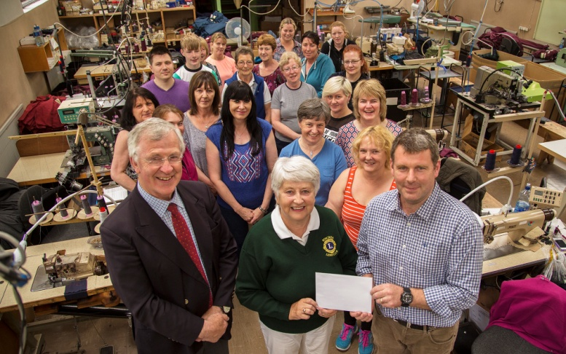
OBITUARIES :

BRENNAN, Lion Larry MJF (71) Lions Club of Ennis
It is with deep regret that we report the passing of Lion Larry, after a short illness, a Charter Member of our Club in 1977, having previously been a member of Freeport Club in the Bahamas.
Larry served in many capacities, including Club President in 1984, the year that saw Bert as IP. He had many skills including a BBQ Chef at Fleadhanna, a log chopper for winter fuel, a barman at the Lions Den in Mosney, a minder in Trabolgan, a food collector, a ticket seller etc. In 1998 he travelled with Bothar to Uganda to see at first hand the impact of their program.
He was a model Lion – quiet, diligent, humorous and never intimidated by any challenge. Earlier this year he played a major role in organising the celebrations of our Ruby Charter.
Her will be sorely missed and never replaced. Our thoughts are with his family at this sad time

Leo and Sean
Leo the Lion with Sean Olohan from Wicklow Lions welcomed Sharon Shannon to Wicklow for her impromptu performance at Sean’s Music Shop Track One. Sharon is a big animal lover so Leo was a big hit with her !

Caring for the Carers
Carers Weekends for 2017 will take place in Ballyvaloo Co Wexford from 3rd. to 5th November
Contact Lion Trina Barnes 087 2263194/ email: barnestrina9@gmail.com for Booking Forms and information re carers weekends in Wexford

Carers Weekend in Yeats County Hotel Rosses Point Co Sligo from17th to 19th November
Contact Lion Mary Henry 0857469530/ email: brenmarhenry@gmail.com for Booking Forms and information re Sligo carers weekends.

Carers Weekends are are very necessary for family carers who look after family members 24/7 The effects on carers can be very stressful, many carers badly need respite from their caring rolls some carers suffer from stress or anxiety. They can avail of counselling. The weekends addresses many problems carers may encounter
Information re benefits/entitlements and training is available to them
Throughout the weekends the carers are made feel at ease they mingle and get to know each other in beautiful tranquil settings and many lasting friendships are made
The weekends conclude on Sunday after a special blessing for carers described as spiritually uplifting
Lions clubs are making a difference by giving Family carers the opportunity of this respite from their caring roles they so badly need and is very much appreciated by carers throughout the country
Lion Mary Henry
Carer's Weekend Coordinator

