ASHBOURNE & DISTRICT ASHBOURNE & DISTRICT LIONS CLUB 2021
LIONS CLUB 2021
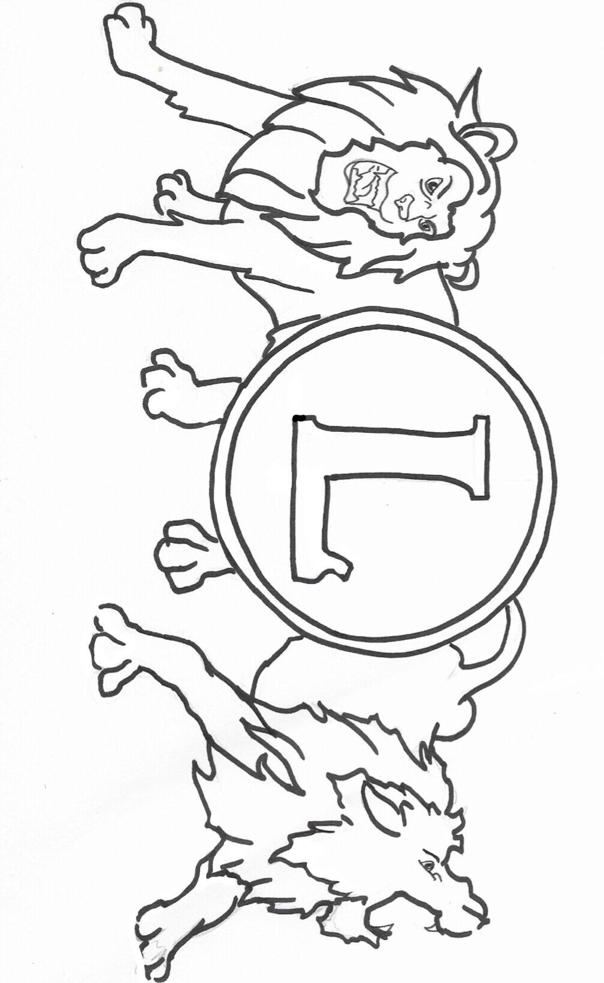
WE SERVE

Charity is important because __________________________________________________________________________________________________________________________________________________________________________
Name : ________________________________________
D.O.B : ________________________________________
Guardian : ______________________________________
Contact Details : _________________________________
School : ________________________________________
Teacher : _______________________________________

( Contact details for the purpose of informing the winners only)

